# Lab: HTML and CSS Basics

## Welcome to HTML

Create a web page like the following:

### Constraints

* Change the file name to **welcome.html***.*
* Use **paragraph** tag for plain text and **strong** tag for bold text.
* Set the title to ***Welcome****.*

## Fruits

Create a web page like the following:

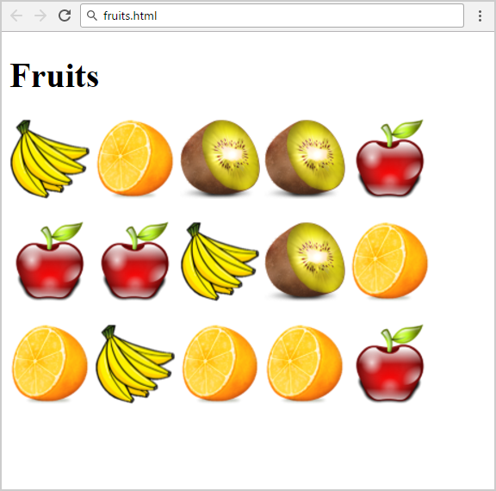

### Constraints

* Change the file name to **fruits.html***.*
* You are given 4 image files: **apple.png**, **banana.png**, **kiwi.png**, **orange.png.**
* Use 3 paragraphs - each holding 5 images.
* Add header **Fruits***.*
* Keep in mind that you need to change the size of the image files to be similar to the example above. You can use the **<style>** tag.

## HTML Lists

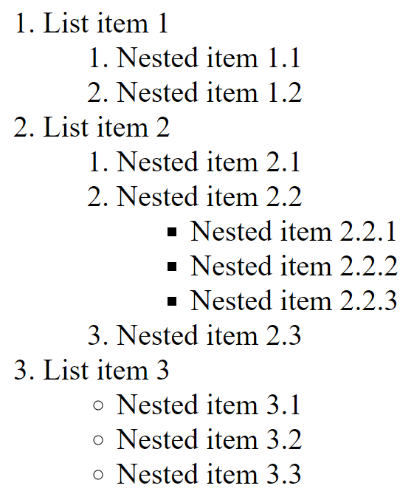

### Constraints

* A nested list like the example

#### Solution

<ol>

<li>List item 1

<ol>

<li>Nested item 1.1</li>

<li>Nested item 1.2</li>

</ol>

<li>List item 2

<ol>

<li>Nested item 2.1</li>

<li>Nested item 2.2

<ul>

<li>Nested item 2.2.1</li>

<!-- TODO: put the next items here-->

</ul>

</li>

<li>Nested item 2.3</li>

</ol>

</li>

<li>List item 3

<ul>

<li>Nested item 3.1</li>

<!-- TODO: put the next items here -->

</ul>

</li>

</ol>

<li>

List item 3

<ul>

<li>Nested item 3.1</li>

<!-- TODO: put the next items here -->

</ul>

</li>

## Wiki Page

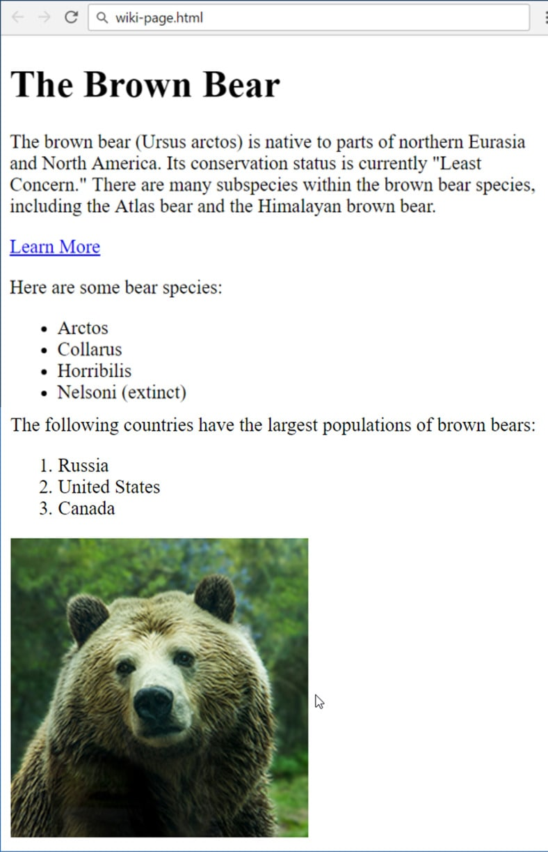Create a web page like the following:

### Constraints

* Filename: **wiki-page.html.**
* Title: **The Brown Bear:**
  + Use **<h1>**
* Hyperlink: **https://en.wikipedia.org/wiki/Brown_bear.**
* List: use **ordered list** and **unordered list.**
* Text: use **paragraph:**
  + Image: use the file **bear.jpg**

## Color Blocks

Use the following HTML:

<div class="green">green block</div>

<div class="blue">blue block</div>

<div class="red">red block</div>

<div class="purple">purple block</div>

<div class="orange">orange block</div>

Аnd style it as the screenshot:

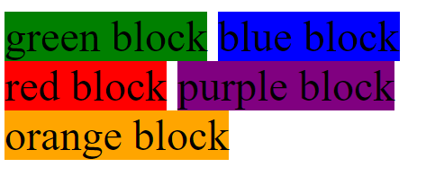

### Solution

div {display: inline-block;}

.green {background-color: green;}

.blue {background-color: blue;}

<!-- Implement rest of the styles -->